
National University of Computer & Emerging Sciences, Karachi
Fall -2024
ASSIGNMENT NO.2 (Oscillations)
18th October 2024
Course Code: NS(1001) | Course Name: Applied Physics
Instructor Name Muhammad Rahim
Student Roll No & Section |  | Submission deadline 03-11-2024
Instructions for Submission:
- Soft copy only
- You are required to Submit the Assignment in softcopy on Google Classroom.
- Strictly follow the deadline

1. What is the phase constant for the harmonic oscillator with the velocity function v(t) given in Fig-1 if the position function x(t) has the form ? The vertical axis scale is set by vs _4.0 cm/s.

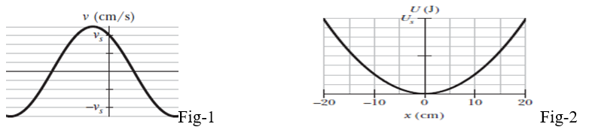

2. Fig-2 gives the one-dimensional potential energy well for a 2.0 kg particle (the function U(x) has the form bx2 and the vertical axis scale is set by Us =2.0 J). (a) If the particle passes through the equilibrium position with a velocity of 85 cm/s, will it be turned back before it reaches x =15 cm? (b) If yes, at what position, and if no, what is the speed of the particle at x =15 cm?

3. A 2.00-kg object is attached to a spring and placed on a horizontal, smooth surface. A horizontal force of 20.0 N is required to hold the object at rest when it is pulled 0.200 m from its equilibrium position (the origin of the x axis). The object is now released from rest with an initial position of xi = 0.200 m, and it subsequently undergoes simple harmonic oscillations. Find (a) the force constant of the spring, (b) the frequency of the oscillations, and (c) the maximum speed of the object. Where does this maximum speed occur? (d) Find the maximum acceleration of the object. Where does it occur? (e) Find the total energy of the oscillating system. Find (f) the speed and (g) the acceleration of the object when its position is equal to one third of the maximum value.
- An automobile can be considered to be mounted on four identical springs as far as vertical oscillations are concerned. The springs of a certain car are adjusted so that the oscillations have a frequency of 3.00 Hz. (a) What is the spring constant of each spring if the mass of the car is 1450 kg and the mass is evenly distributed over the springs? (b) What will be the oscillation frequency if five passengers, averaging 73.0 kg each, ride in the car with an even distribution of mass?
- In Fig: 3 two identical springs of spring constant 7580 N/m are attached to a block of mass 0.245 kg. What is the frequency of oscillation on the frictionless floor?
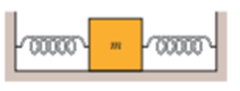Fig:3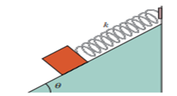Fig:4
- In Fig 2, a block weighing 14.0 N, which can slide without friction on an incline at angle 400), is connected to the top of the incline by a massless spring of unstretched length 0.450 m and spring constant 120 N/m. (a) How far from the top of the incline is the block’s equilibrium point? (b) If the block is pulled slightly down the incline and released, what is the period of the resulting oscillations?
- Two particles oscillate in simple harmonic motion along a common straight-line segment of length A. Each particle has a period of 1.5 s, but they differ in phase by π/6 rad. How far apart are they (in terms of A) 0.50 s after the lagging particle leaves one end of the path? What are their velocities after 0.50 s ?
- Two particles oscillate in simple harmonic motion along a common straight-line segment of length A. Each particle has a period of 1.5 s, but they differ in phase by π/6 rad. How far apart are they (in terms of A) 0.50 s after the lagging particle leaves one end of the path? What are their velocities after 0.50 s ?

9. Determine whether the following quantities can be in the same direction for a simple harmonic oscillator: (a) position and velocity, (b) velocity and acceleration, (c) position and acceleration.
A block–spring system undergoes simple harmonic motion with amplitude A. Does the total energy change if the mass is doubled but the amplitude is not changed? Do the kinetic and potential energies depend on the mass?

10. In an engine, a piston oscillates with simple harmonic motion so that its position varies according to the expression
x= (5.00 cm)cos(2t +π/6)
where x is in centimeters and t is in seconds. At t =0, find (a) the position of the piston, (b) its velocity, and (c) its acceleration. (d) Find the period and amplitude of the motion.
11. A 2.20 kg mass oscillates on a spring of force constant 250 N/m with a period of 0.615 s. (a) Is this system damped or not? How do you know? If its is damped find the damping constant b. (b) Is the system undamped, underdamped, critically damped or overdamped? How do you know?
12. When displaced from equilibrium, the two hydrogen atoms in an H₂ molecule are acted on by a restoring force F_{x} = -kx with k = 580 N/m. calculated the oscillation frequency of the H₂ molecule.
13. A 1.50 kg, horizontal, uniform tray is attached to a vertical ideal spring of force constant 185 N/m and a 275 g metal ball is in the tray. The spring is below the tray, so it can oscillate up and down. The tray is then pushed down 15.0 cm below its equilibrium point (call this point A) and released from rest. (a) How high above point A will the tray be when the metal ball leaves the tray? (b) How much time elapses between releasing the system at point A and the ball leaving the tray? (c) How fast is the ball moving just as it leaves the tray?
14. At t = 0, the displacement of a point x (0) in a linear oscillator is – 8.6 cm, its velocity v (0) = – 0.93 m/s and its acceleration a (0) is + 48 m/s2. (a) What are the angular frequency
w and the frequency n ? (b) What is the phase constant? (c) What is the amplitude of the motion?

